CloudActiv8 Support

Business Management Solution

Evaluation Quick Start Guide

**Copyright Agreement**

The purchase and use of all Software and Services is subject to the Agreement as defined in CloudActiv8’s “Click-Accept” EULA as updated from time to time by CloudActiv8 at http:/[/www.CloudActiv8.com](http://www.kaseya.com/jp/legal.aspx)/legal.aspx. If Customer does not agree with the Agreement, please do not install, use or purchase any Software and Services from CloudActiv8 as continued use of the Software or Services indicates Customer’s acceptance of the Agreement.”

Contents

Adding an Employee into HR folder 4

Adding Roles to an Employee Record 5

Creating an Account in the CRM Module 5

Adding a Contact in the CRM Module 7

Creating a New Ticket in the Service Desk Module 8

Accessing Tickets and Entering Time and Notes 9

Creating a Project in the Projects Module 11

Creating Project Tasks and Assigning to Employees 13

Entering Time and Notes on Project Tasks 15

Approve and Post Process 17

Billing Process 18

Create Product Categories 22

Managing Inventory 23

Creating Sales Quotes 24

Creating Reports 25

Thank you for evaluating Support by CloudActiv8. As part of the trial process, we have included this Quick Start Guide – designed to help you navigate through the most common activities in the solution. Feel free to review and use these instructions to assist you in the trial of your Support Implementation.

# Adding an Employee into HR folder

1. Go to **Admin Module** ‘ **HR** ‘ **Employees** ‘ **New**

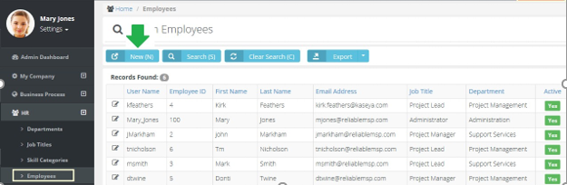

1. Fill in, and select from drop-down menus, information in all required fields indicated by Q

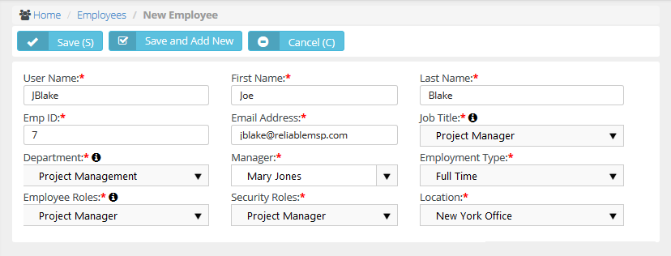

1. Click the **Save** button.

Support will automatically send an email with login credentials to the new user.

# Adding Roles to an Employee Record

1. Go to **Admin** ‘ **HR Folder** ‘ **Employees** (Open an Employee Record)

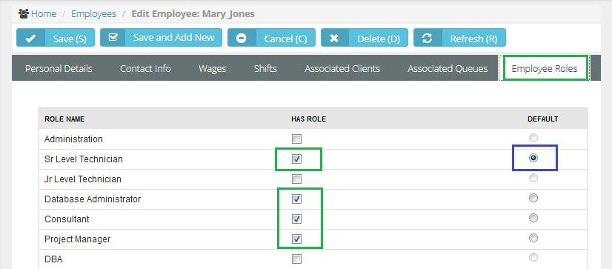

1. Add the Role(s) this employee has.
2. Set the Default Role. *(This role will appear when the employee enters time on Ticket or Task)*

**Note:** You can change role rate if you need to charge another client a different rate for Time and Material work. You create a NEW Time and Material Contract in the Finance Module. No need to create too many roles

# Creating an Account in the CRM Module

In order to create contracts and open support tickets and manage projects for our customers you need to enter those customers into the CRM Module.

1. Go to **CRM** ‘ **Accounts** Click on the **New** button.

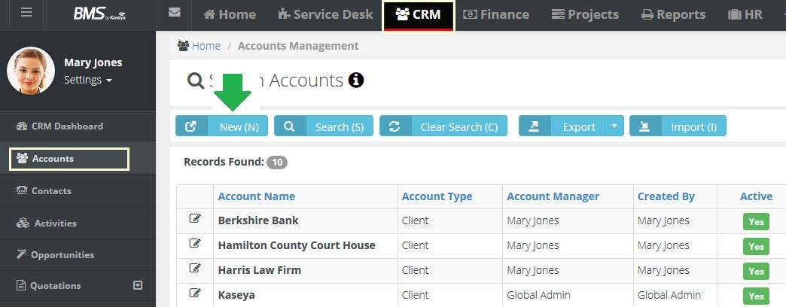



1. Fill in, and select from drop-down menus, information in all required fields indicated by Q

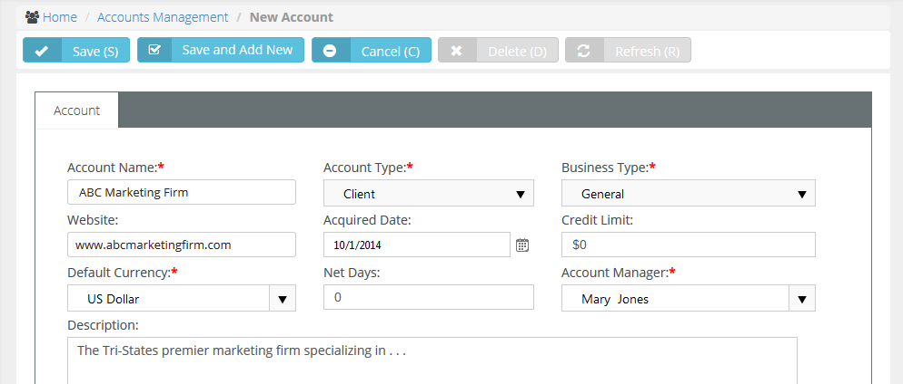

1. Click the **Save** button.

**Note:** You can add the address information at any time, but for Quick Start purposes, you have enough information now to use this account in testing.

# Adding a Contact in the CRM Module

Now that we created an Account, let’s add a contact to this Client record. Why?

n You open Tickets for contacts when they call looking for support

n Contacts send emails to [support@yourcompany.com](mailto:support@yourcompany.com)

n Email notifications are auto sent to contacts (example – close a ticket)

n Quotes and Invoices are sent to Contacts

1. Go to **CRM** ‘ **Accounts** Open the Account you just created *(example here is ABC Marketing)*

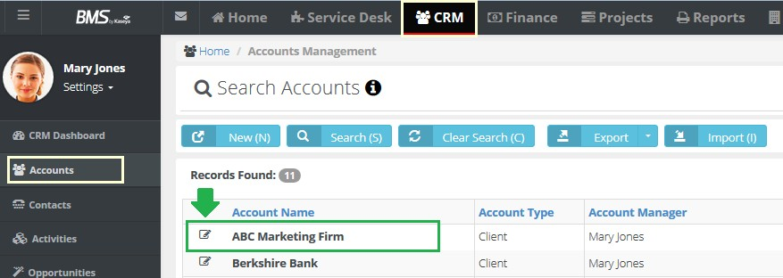



1. Look at the lower section of **Account** and click **Account Contacts** and click on the **Add** button.

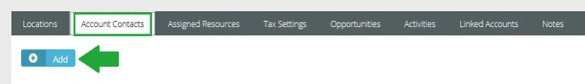

1. Fill in, and select from drop-down menus, information in all required fields indicated by Q

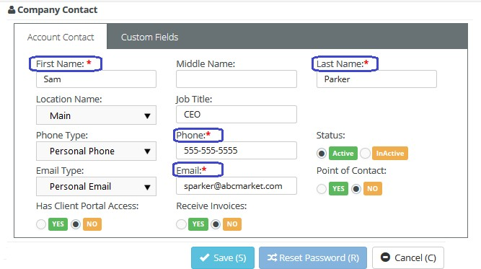

1. Click the **Save** button.

# Creating a New Ticket in the Service Desk Module

Tickets are used to capture a Customer issue and assign to the appropriate employee(s) to work and resolve that issue.

The Support solution allows you to create service tickets in a number of ways:

n Alerts from an RMM like CLOUDACTIV8 → create tickets

n Emails sent to [Support@yourcompany.com](mailto:Support@yourcompany.com) → create tickets

n Client Portal Submissions → create tickets

n Clicking the NEW ticket if you take a support call

Let’s create a Ticket based on taking a call form a customer

1. Go to **Service Desk** ‘ **Tickets** ‘ **New**

New Ticket

You can also click the Blue New Ticket button along the top

1. Fill in, and select from drop-down menus, information in all required fields indicated by Q

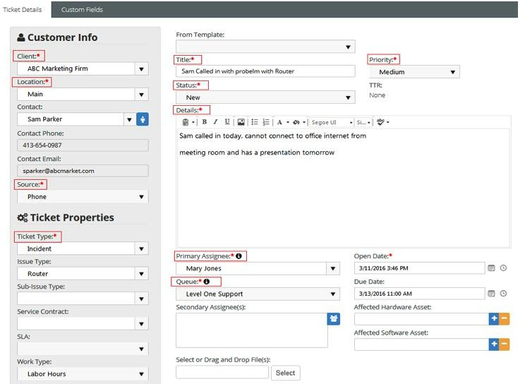

1. Click the **Save** button.

# Accessing Tickets and Entering Time and Notes

When Tickets are created in the Support, a Service Desk Manager will see and have access to ALL tick- ets in the Service Desk Module via:

n Service Desk Dashboard (Status / Priority / Assignee / Queue / Issue Type)

n Tickets Folder

n Recurring Master Tickets

n Service Calls

Your employees will find tickets assigned to them in their Home Module.

1. Go to **Home** ‘ **My Tickets** Click on Ticket Number or Pencil Icon 

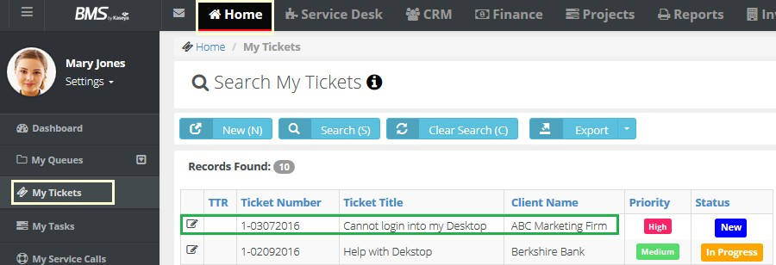



1. When Ticket is open, look to bottom and click on the **Add Time** button

*(Or Click on the Time Logs Tab and click Add Time)*

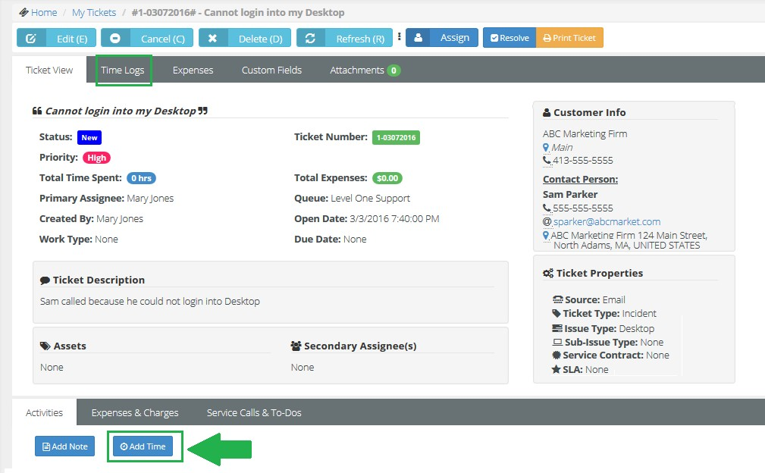

1. After you click on the **Add Time** button the following screen will appear.

Fill in, and select from drop-down menus, information in all required fields indicated by Q

**Note: General Notes** are public facing. **Internal Notes** are seen by employees and not clients.

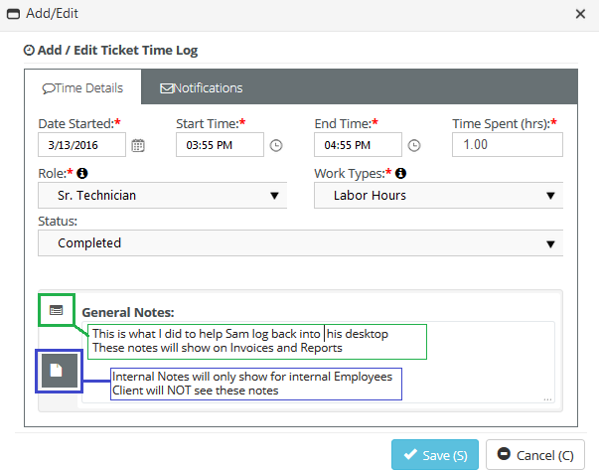

1. Click the **Save** button.

This Time entry has updated many forms including:

n Time will now be captured on the Ticket

n The employee’s Time sheet will be updated.

n You can review the Labor Entry in the Finance Module to create an Invoice.

# Creating a Project in the Projects Module

Projects in the Support can be created in a number of ways:

n Create the Project from scratch – adding Tasks and Employees

n Copy an existing Project

n Cloning a Project from the Template Project folder

1. 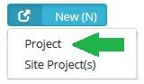Go to **Project** ‘ **All Projects** ‘ **New**

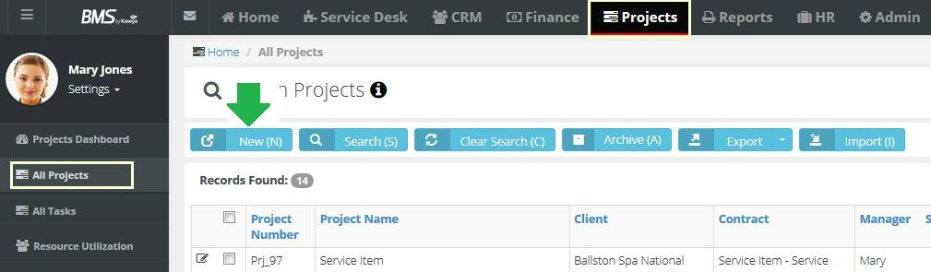



1. Click on the **New** button and select Project You will get the following screen...

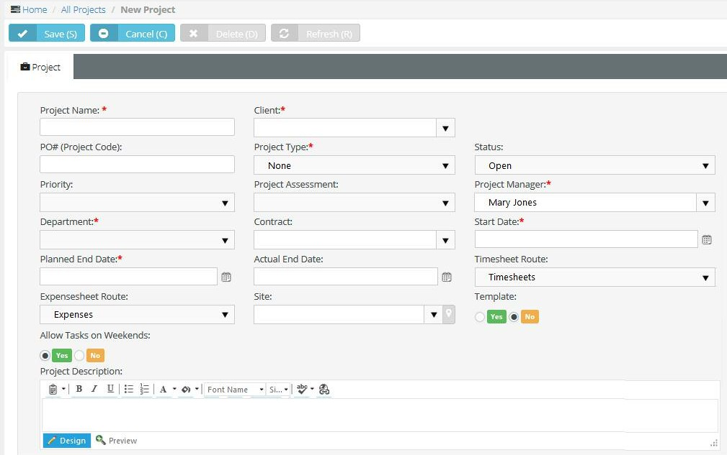

1. Fill in, and select from drop-down menus, information in all required fields as well as any applicable fields

**Project Name\*** Name of the project.

**Client\*** Client you are performing work for (Client form CRM).

**Project Type\*** Used to track projects – Types can be configured.

**Status** You should leave it as an OPEN status if this project is active and you want employees to enter time/expenses against it.

**Project Manager\*** Who is managing this project within your organization? Required

**Department\*** Track which Department is leading the project. Can report on Projects by Department.

**Contract** You can select a contract that will manage how time entered is billed for this project. ( Example - Fixed Price Contract)

**Start Date\*** The first day work on this project will begin. All tasks must have a start date equal or greater than the start date of the project. You can adjust this if needed.

**Planned End Date\*** The Day you are targeting to end this project.

**Actual End Date** The day you actually complete the project and set to Closed

**Timesheet Approval Route** Select which approval route flow you want submitted Timesheets to follow for this specific project. If NONE is selected, then you are telling the system to Auto-Approve all submitted Timesheets for this project only.

**Expense Approval Route** Select which approval route flow you want submitted Expense Sheets to follow for this specific project. If NONE is selected, then you are telling the system to Auto-Approve all submitted expenses for this project only.

**Project Description** A description of this project – who, what, where, when and why?

1. Set the Planned Budget and Planned Hours

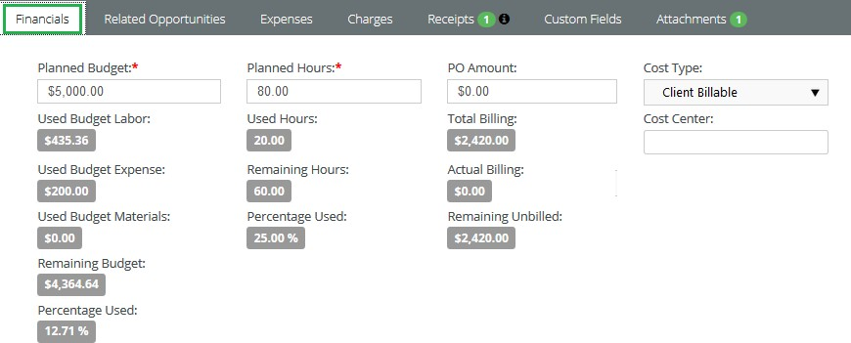

# Creating Project Tasks and Assigning to Employees

A Project without a Task(s) is only a static holder of project related information (Name, budget, manager, costs, etc.)

Tasks are what make a project interactive, dynamic, and make it possible to track its progress

Tasks are what employees enter time against and it updates their timesheets automatically – eliminating the need for double and triple entry

1. Go to **Tasks Tab** on our New Project

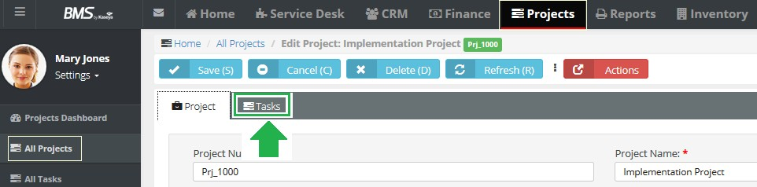



1. Click the **Add Task** button and then select the **Task** tab

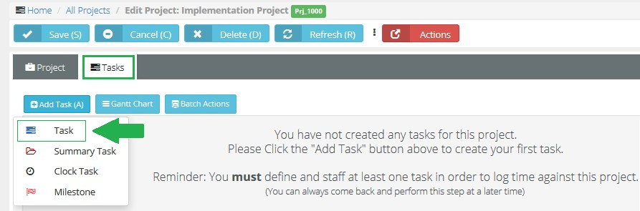

1. Fill in, and select from drop-down menus, information as indicated on the following page.

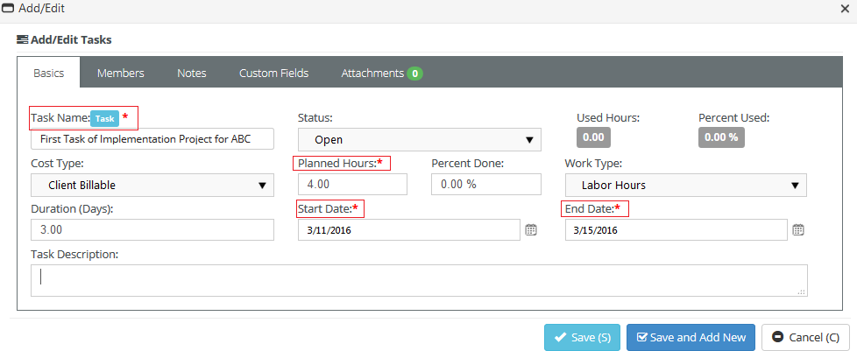

**Task Name\*** Name of the task.

**Status\*** Set to Open.

**Cost Type\*** Set to Client Billable

**Planned Hours** How long should it take to complete? - Can be “0” hours

**Work Type** Set to Labor Hours

#### Start Date* and End Date*

1. Click the **Save** button.

Adding Employee(s) to the Task

**1.** Go to the **Members** tab on the Task and Tasks Tab on our New Project

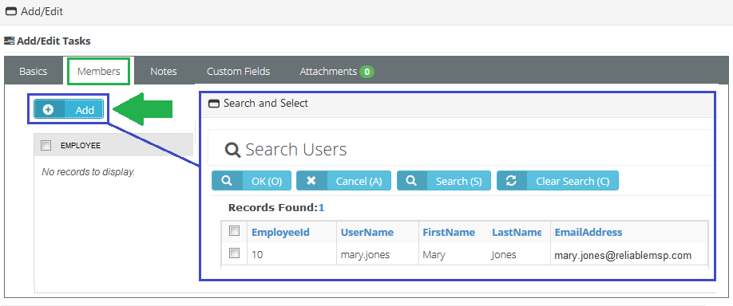

The Project Manager will see Task on Project Schedule

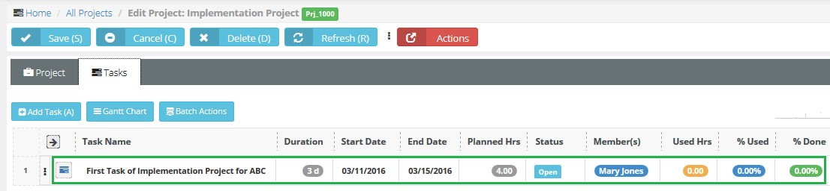

Your employees will find tasks assigned to them in their Home Module

# Entering Time and Notes on Project Tasks

In the Support, your employees can track time worked on any Project Task they are assigned to. Time entries here, just like tickets, can be used to generate line items on an invoice.

1. Go to **Home** ‘ **My Tasks** and click on Task Name or Pencil Icon 

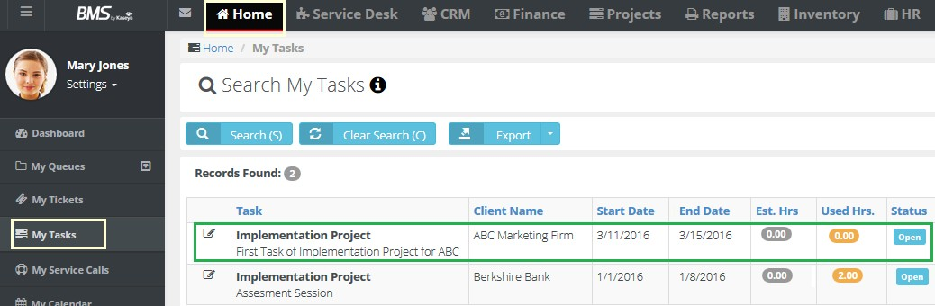



1. Select the **Time Logs** tab and then click the **Add** button

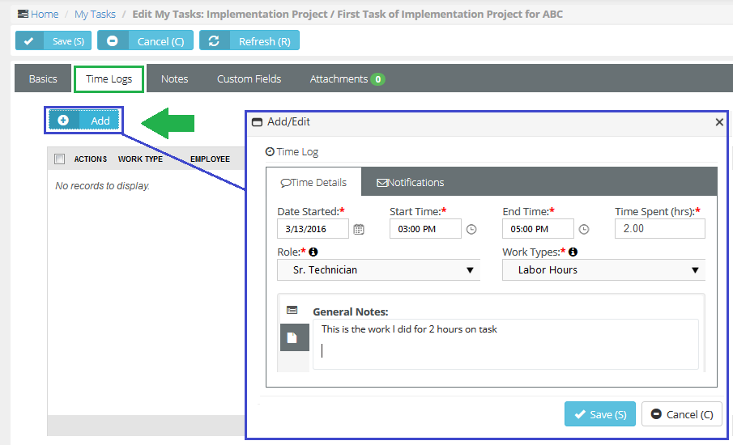

1. Fill in, and select from drop-down menus, information in all required fields. Remember that General Notes are public facing.
2. Click the **Save** button.

n This Time entry will now be captured on the Projects Info tab (total hours)

n The employee’s Time sheet will be updated.

n You can review the Labor Entry in the Finance tab to create an Invoice

# Approve and Post Process

The Time entered on our Ticket and Task is now sitting in the Finance Folder ready to go through the Approve and Post Process

1. Go to **Finance** ‘ **Billing Review** ‘ **Labor Hours**

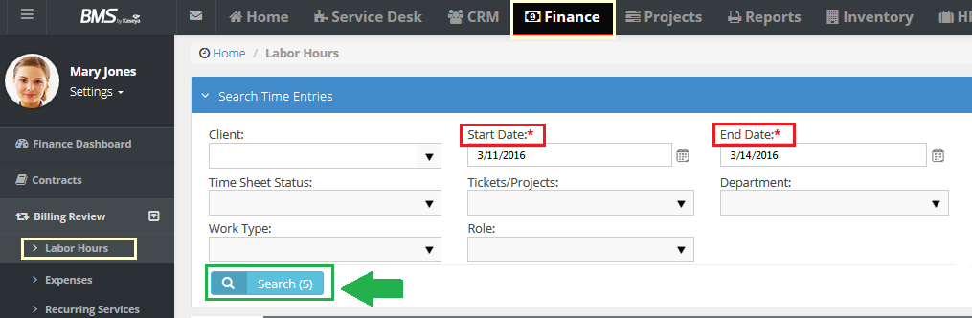



You can use the Search Grid to filter the data.

1. Click on the **Search** button and you will see the results below.

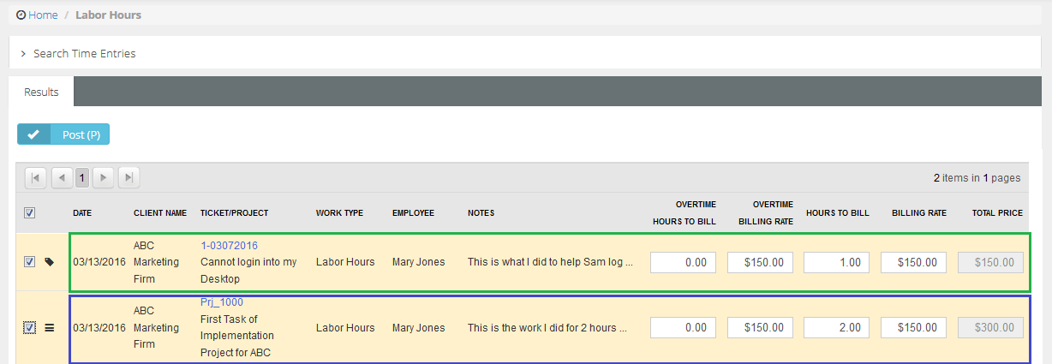

In this example, we see two time entries made by employees:

The first line record is time posted against a Ticket (1 hour @ $150)

The second line record is time we posted against a Task (2 hours @ $150) You can adjust the Hours to Bill and Billing Rate if needed.

1. To approve and post, check the boxes next to the entry and click on the **Post** button



# Billing Process

After reviewing Labor Hours and approving the time entries, these items have moved into the Billing Folder

Here you can combine these Labor Hours with other items you may wish to invoice:

n Expenses added to a ticket or project

n Recurring Service Contracts

n Fixed Price Contract Milestones (ex – Deposit or Final Project Payment)

n Retainer Hour Contracts (some call them Block Hours)

1. Go to **Finance** ‘ **Billing Review** ‘ **Billing**

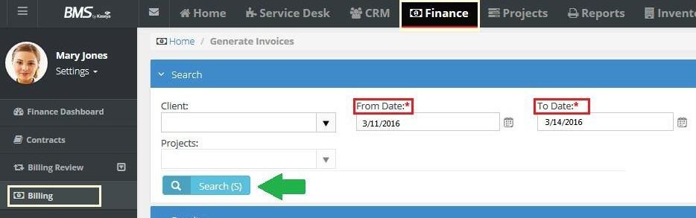



You can use the Search Grid up top to filter the data.

1. Click on the **Search** button and you will see the results below.

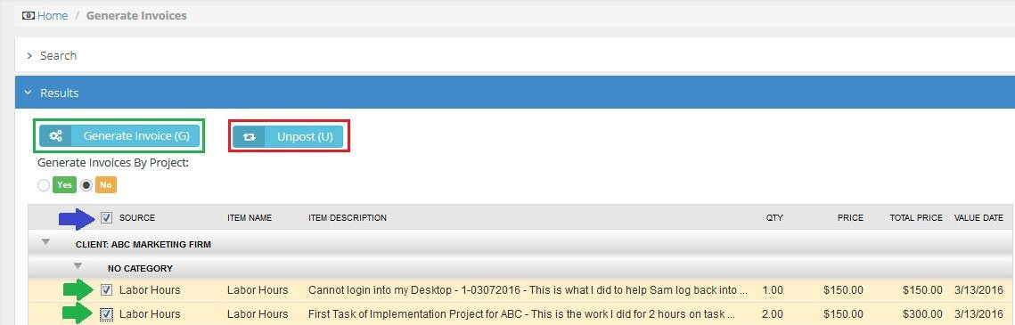

The Client is listed in the gray bar = ABC Marketing Firm

The first line record is Labor Hours posted against a Ticket (1 hour @ $150) The second line record is Labor Hours posted against a Task (2 hours @ $150)

1. Check the boxes next to the entry to be billed and click on the **Generate Invoice** button

**Note:** You can UNPOST these records if you see an error. It will place them back in the Billing Review folder where you can make adjustments and walk through process again.

Billing Process

All the items that have been Reviewed and Approved and Generated are now sitting in the Invoice Folder with the Status of NEW

When we moved the items from Billing to the Invoice folder it assigned the next Invoice number in line (example Inv_108)

You can now make adjustments before creating the final Invoice and sending to your client or transferring to QuickBooks:

n Add additional information to Line items or a Note on Invoice

n Adjust Quantity or Unit Price

n Apply a Discount – a dollar or percentage amount

n Attach Receipts (that flowed through system to final invoice)

n Add any additional attachments

1. Go to **Finance** ‘ **Invoices** Click on Invoice Number or 

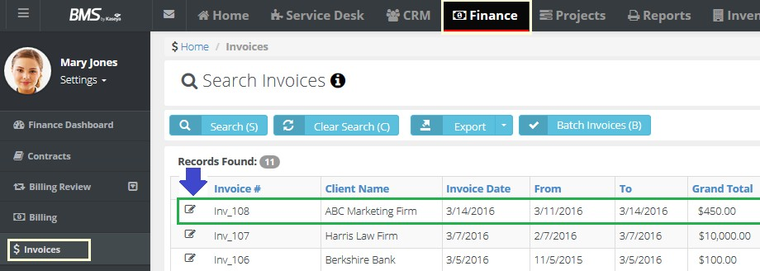



1. After you open Invoice click on the green **Generate** button along the top.

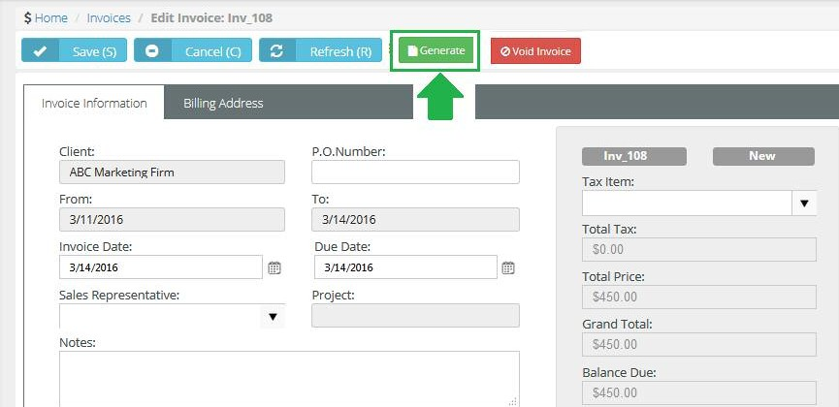

1. After clicking on the green **Generate** button, you can select an invoice template. Select the template and click the **Generate** button

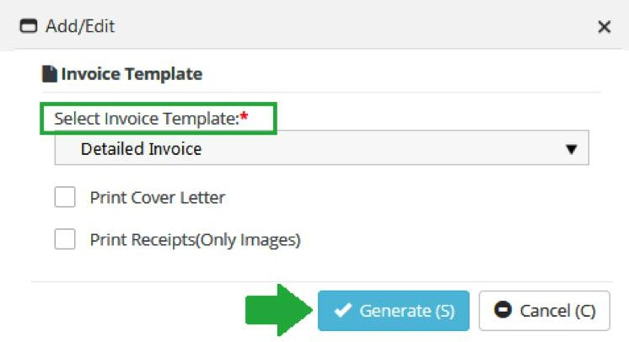

Your Invoice buttons along the top will now include more options.

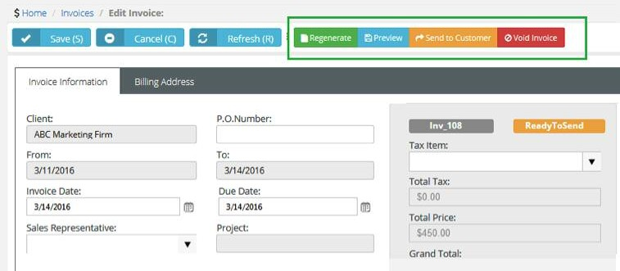

The Status of your Invoice is now READY TO SEND

n You can Preview your Invoice

n You can Regenerate

n You can send to your customer

n You can Void the Invoice if necessary which places items back into Approve and Post.

**Note:** All invoices with READY TO SEND or SENT statuses are now sitting in the QuickBooks folder in the Finance Module ready to sync with QuickBooks (if configured).

Inventory, Warehouse Locations and Product Categories

Support comes with an Inventory Module that helps you:

n Store Inventory in Multiple locations

n Maintain Products Lists so you can:

n Manage the Inventory Process (maintain levels of Inventory, Generate Purchase Orders and Replenish Stock)

n Use as Products Catalog so you can create Quotes in the CRM

Create Warehouse Locations

1. Go to **Admin** ‘ **Inventory** ‘ **Warehouse**

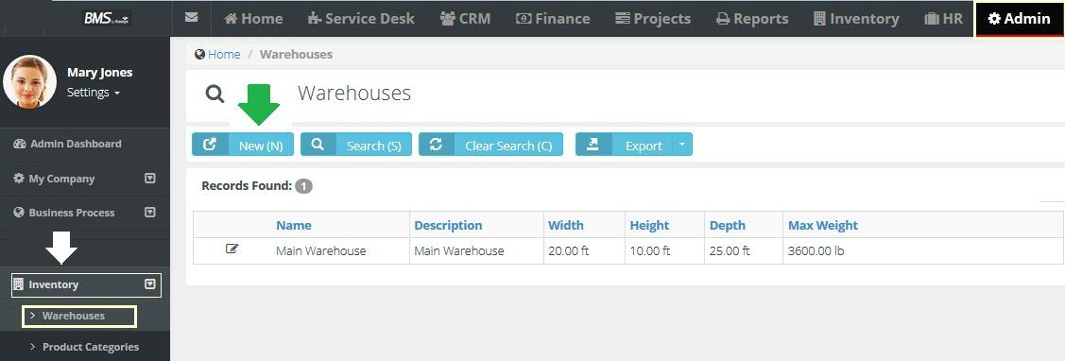



1. Fill in, and select from drop-down menus, information in all required fields and make sure to include the address of the warehouse.

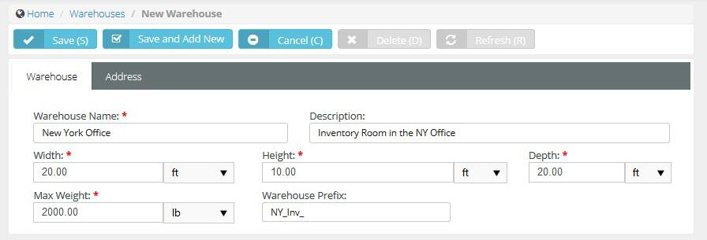

1. Click the **Save** button.

# Create Product Categories

1. Go to **Admin** ‘ **Inventory** ‘ **Product Categories**

1. Click the **New** button.

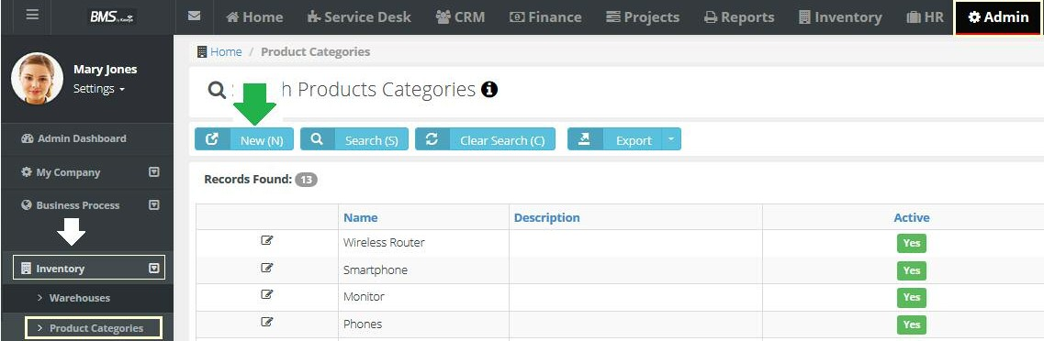



1. Fill in information in all required fields.

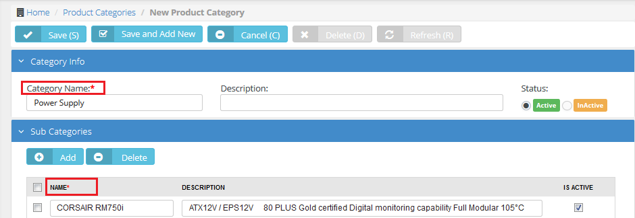

1. Click the **Save** button.

# Managing Inventory

In the Inventory Module, you will manage your Products by warehouse location

**1.** Go to **Inventory** ‘ **Products** ‘ **Product Availability**

Here you will enter product information and location.

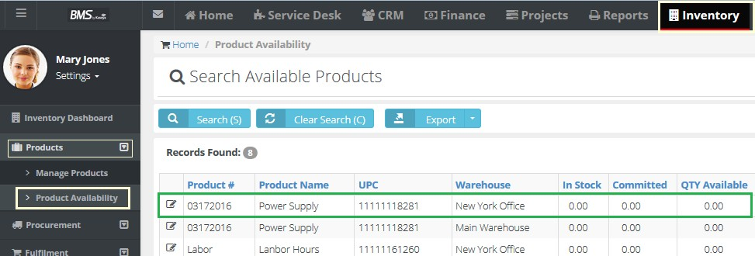



# Creating Sales Quotes

In the CRM Module, you will use the Products created in the Inventory to generate Sales Quotes

1. Go to **CRM** ‘ **Quotations** ‘ **Product Quotations**

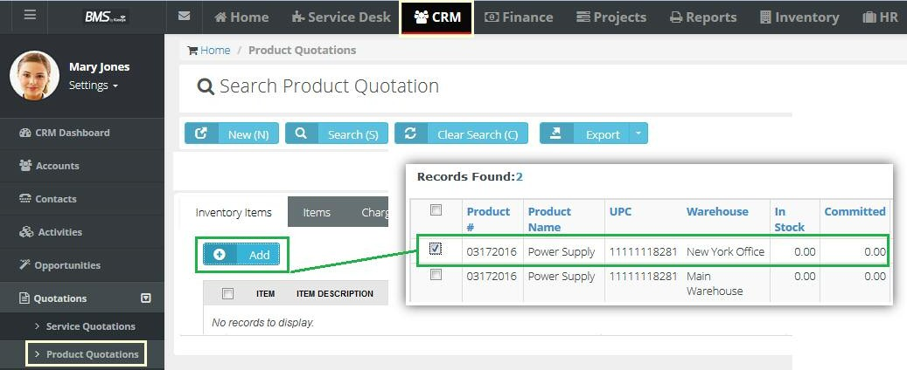



1. Click the **New** button.
2. Fill in information in all required fields.
3. Click the **Add** button under Inventory Items and select the Product you wish to quote.
4. Click the **Save** button and send quote to prospect.

# Creating Reports

Support comes with Reports for each Module

1. Go to **Reports** ‘ **Reports Dashboard**

Click on the Module you want to create a report for. ( Service Desk is selected in this example)

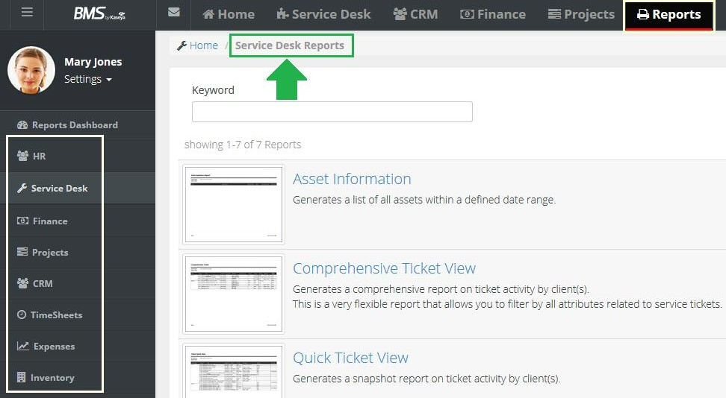



1. Click on the Name of the Report you want to generate.

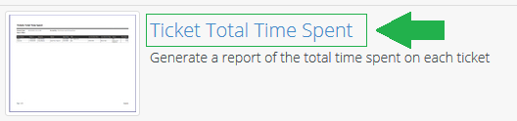

1. Then use the Search Grid to produce desired output and Click on **Search**

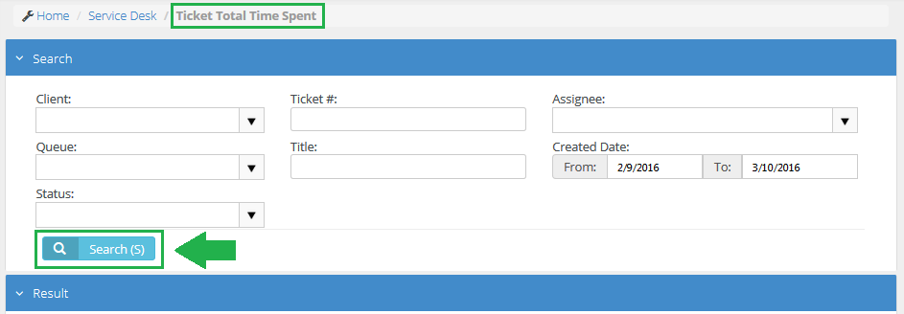

You will see your Report under the Results banner.

1. Choose to print or export the report in a variety of formats

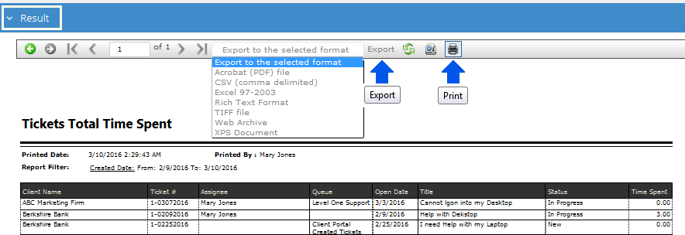

**ABOUT CLOUDACTIV8**

CloudActiv8® is the leading provider of complete IT management solutions for Managed Service Providers and small to midsized businesses. CloudActiv8 allows organizations to efficiently manage and secure IT in order to drive IT service and business success. Offered as both an industry-leading cloud solution and on-premise software, CloudActiv8 solutions empower businesses to command all of IT centrally, manage remote and distributed environments with ease, and automate across IT management functions. CloudActiv8 solutions currently manage over 10 million endpoints worldwide and are in use by customers in a wide variety of industries, including retail, manufacturing, healthcare, education, government, media, technology, finance, and more. CloudActiv8, headquartered in Dublin, Ireland is privately held with a presence in over 20 countries. To learn more, please visit [**www.CloudActiv8.com**](http://www.kaseya.com/)

©2020 CloudActiv8. All rights reserved. CloudActiv8 and the CloudActiv8 logo are among the trademarks or registered trademarks owned by or licensed to Virso Limited. All other marks are the property of their respective owners.